

RAINER B. SCHMITZ  PARTNER, EXECUTIVE COACH  HEAD OF TPA ASIA – SINGAPORE, SEA and INDIA | rainer.schmitz@theprestonassociates.com  T: +44 (0)20 7373 5663

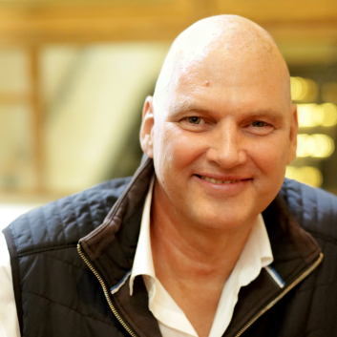 | “A Reflective Thinking Partner for Executives Navigating Complex Business Landscapes”  Rainer’s coaching style is clear, direct, impactful, and empathetic, while maintaining the ability to constructively challenge his clients. He combines a high degree of integrity, gentleness, and excellent listening skills with a straightforward approach, strong discipline, and keen intuition, enabling him to accurately read the dynamics in the room.  As a Thinking Partner, Rainer helps executives enhance individual, team, and business performance. He provides the reflective space needed to drive meaningful business outcomes.  Areas of expertise: High Performing Teams | Effective and authentic leadership | Inspire to drive engagement | Leadership through Coaching | Effective Key Stakeholder Management and navigating the System.
EXPERIENCE

Rainer began coaching executives in 2006 while living in Asia. He has worked with senior executives and executive teams across sectors including FMCG, financial services, pharma, chemicals, beverages, and the automotive industry. Most recently, Rainer held senior positions in Asia, including Director of Human Resources China for Mondelez International (formerly Kraft Foods), where he was responsible for 7,000 employees, the integration of a major business following an acquisition, and a rapidly growing business. He then became Director of Global Talent Management for Bacardi Asia Pacific & Global, responsible for global leadership development, creating a Global Coaching Roadmap, and supporting the Asia Pacific region. Throughout his career, Rainer has focused on being a genuine business partner, taking accountability for driving the performance of individuals and teams across the organizations he has served.
EDUCATION, QUALIFICATIONS, PROFESSIONAL MEMBERSHIPS

- ECCP Certified Coach
- Barefoot Certificate in Business and Personal Coaching
- Member of EMCC (European Mentoring and Coaching Council)
- Advisory Board Member of Asian Charity Organization

